

Marralomeda Newsletter
Summer 2021

Update from Community Leader-

It has been a busy start to 2021, as expected. The Community Members all enjoyed a great Christmas break with many of them going on various outings and enjoying different activities. A number of people also went home for Christmas to enjoy time with their family, which is always a highlight.
Our new house at 17 Mottram St has now been renovated and the finishing touches have been completed. We have applied for the final sign off from the Council. This has been a major piece of work that has taken nearly two years! Our thanks go to Board member Tom Logan who has helped to co-ordinate everything. We hope to move in near the end of March.
With the addition of another house, it has given us the opportunity to talk with Community Members about where they are currently living. Some people will be able to move to live with people who they are more compatible with. I have had a number of discussions with Community Members about this. We have also looked at our staff resource and tried to ensure we have the best match of skills and experience with people’s support needs. As a result, there will be several people moving when the new house opens.
Another exciting decision that has been made is naming the new house so it reflects the spirit and philosophy of Marralomeda. After consultation with the Board, Community Members and staff, the decision has been made for the new house to be called “Annie Margaret” house. This name has been decided upon as it acknowledges Annie Miller and Margaret Bowring who were the first two women to come and live with Anne-Marie and Roger 31 years ago to begin the journey of ‘Marralomeda- The Best Place on Earth.’ I talked with Annie and Margaret’s families and they were both delighted to have the name of their sister given to the house.
The proposed houses are as follows-
Annie Margaret | Ena Adams | Kowhai | McAuley | McHale
-Sarah  -Amy  -Pat  (2 vacancies) | -Brian  -Judith  -Margaret  -Jill  (1 vacancy) | -Jane  -Virginia  -Kathryn  (2 vacancies) | -Joan  -Karen  (2 vacancies) | -Susan  -Neville  -Nigel  -Michael
Residential Assistants-  -Sharmi  -Lorna | Residential Assistants-  -Glory  -Anna | Residential Assistants-  -Kaliti  -Karen | Residential Assistants-  -Angelique  -Heather | Residential Assistants-  -Janese  -Jack

We are also working on transition planning with some new families who want to join the Marralomeda Community. I won’t name the new people until things are all confirmed so I have just noted where the vacancies are. The transition planning has been difficult due to the lack of an end date for the new house to open and also the number of disruptions with Covid alert level changes over the past year. Thank you everyone for your patience!
Our recent return to Level 2 was an unexpected hiccup however everyone at Marralomeda is used to adapting and being flexible when required. We returned to our system of two lots of two-house bubbles and minimised anyone coming to Marralomeda. Some of the day services were closed so we had two houses come to the Pike Centre each day and people from the other two houses were supported at home. This seemed to work well however we were pleased when we returned to Level 1 after the three days. It is a reminder of how quickly things can change. We continue to use safe hygiene practices and contact tracing for both Community Members and staff.
Our Staff were looking forward to a one-day Staff Retreat in February. However, due to the introduction of Covid Level 2 we had to delay this. It will now be held in June. At this retreat we will focus on ‘What is Prayer’ and staff will benefit from additional resources to add to their tool kits to support Spiritual development for both themselves and the Community Members.
Marralomeda has been involved in a research project with some other disability support organisations on developing tools to support people with learning disabilities to write their Advanced Care Plan. This research has been led by Nic McKenzie. The Advanced Care Plan template is now finished and ready for the people involved in the project to trial. Once we have completed this with the people involved, there may be some further development of the resource by Nic and her team. We hope to be able to utilise this tool with other Community Members who want to plan for their end of life wishes once it is available for wider use.
Marralomeda purchased new computers at the end of last year. Our computers were getting quite old and needed an upgrade. We also introduced a cloud-based system for storing our records which should be more reliable and easier for everyone to access when they need to. Previously the house staff were unable to access the shared drive for information. These changes should improve communication between everyone. We have retained some of the old computers so they can be available for Community Members to utilise at the Pike Centre or at home.
Marralomeda is pleased to be involved in a series of System Transformation Workshops. There are four locations around the country and we are sharing this six month learning in Christchurch with Hohepa and Skillwise. We want to ensure Marralomeda responds to Community Member’s specific hopes and dreams for their lives and that we are supporting people in a way that is consistent with the eight Enabling Good Lives Principles (which are Self Determination, Beginning Early, Person Centred, Ordinary Life Outcomes, Mainstream First, Mana Enhancing, Easy to Use and Relationship Building.) It is evident from our discussions that there are many great things we are doing at Marralomeda to ensure people live their best life. As with everything, it is always good to build on what we are currently doing and look at new things as well. The team working on this are Karen Robson, Sharyn Smallridge, Gina Lyall, Ruth Jones and myself. You will hear more about this in future newsletters.
We have been communicating with the Catholic Parish of Christchurch North about re-enacting the Stations of the Cross at St Gregory’s church on Good Friday, 2nd April at 10am. Marralomeda has been involved in this for many years now and we are pleased to be providing this again in 2021. Everyone is welcome to attend.

Karen Rickerby
Community Leader

Update from Marralomeda Board-
The Marralomeda trustees welcomes a new year like many other people around the world. 2020 was extremely tough and we acknowledge the leadership team and staff for keeping the community members safe. We also thank and celebrate the community members for their tenacity and spirit during 2020 and the much more recent Alert Level changes. We are blessed to be in Aotearoa with such huge impacts clearly evident elsewhere due to COVID.
The new year brings hope and warmth but also a time of reflection – we especially hold in our hearts and prayers community members Monica Cavanagh and Pam Miles who passed away last year.
While this summer brought a wee bit of variable weather to Otautahi we were delighted to witness and see photos of the many trips and activities that community were a part of. There was a lot of opportunities to get out and about over the holiday period and for those days people stay at home the gardens at Marralomeda remain beautiful and a real pleasure for all of the community.
Lastly the trustees are so excited that the whare owned by Anne Marie and Roger is very nearly ready to be reopened as Annie Margaret House named after the two original community members – what a stunning legacy and exciting journey forward. A big thanks to Tom Logan who has done so much work and used his expertise in the building industry to get the house to this point. We look forward to the blessing of the house and the new adventures and memories that will become part of our ongoing story

Community Activities-
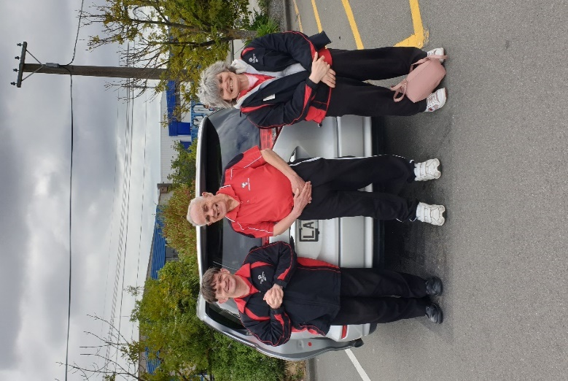
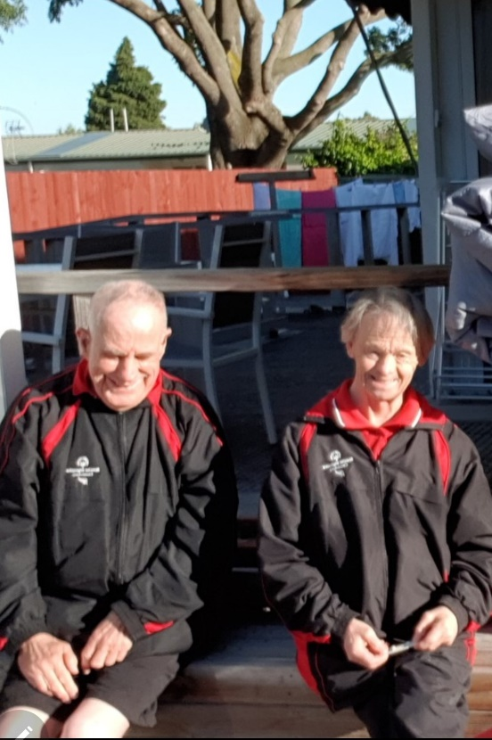
Brian and Michael enjoy some time in the sun before going to the first day of Ten Pin Bowling

Michael, Brian, and Karen waiting to go back home after their first day back to Ten Pin Bowling for 2021

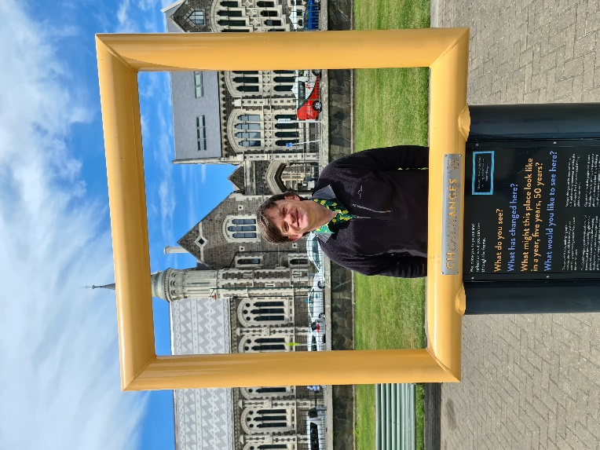
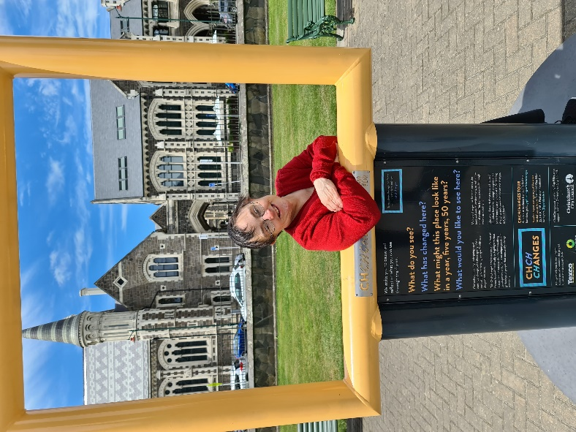

Jane, Michael and Karen enjoying a day out in the city
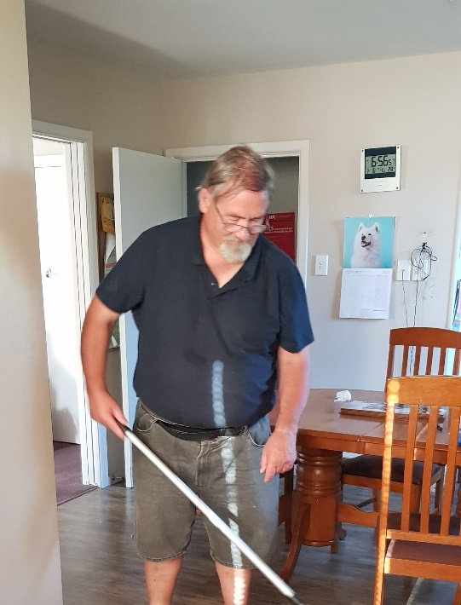
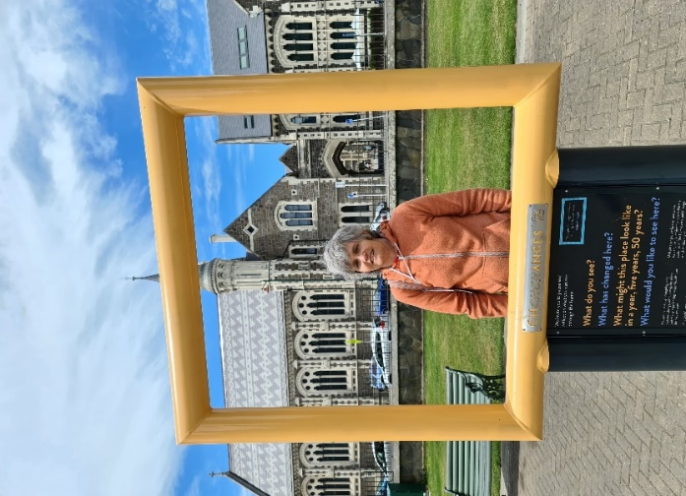

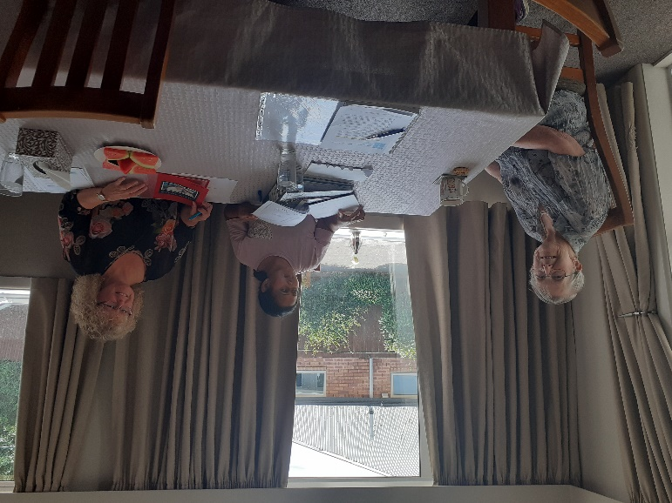
Neville tackling his household chores with a smile

Judith shares her ideas and goals with Sharmi and Gina at her recent planning meeting


Community Corner
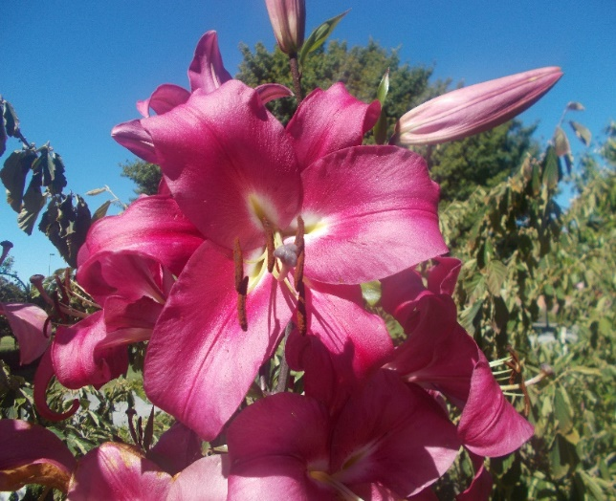
Some of the Community Members love to take photos. Here are some of the photos that Brian has taken at Mona Vale and Jane took at the Botanical Gardens.
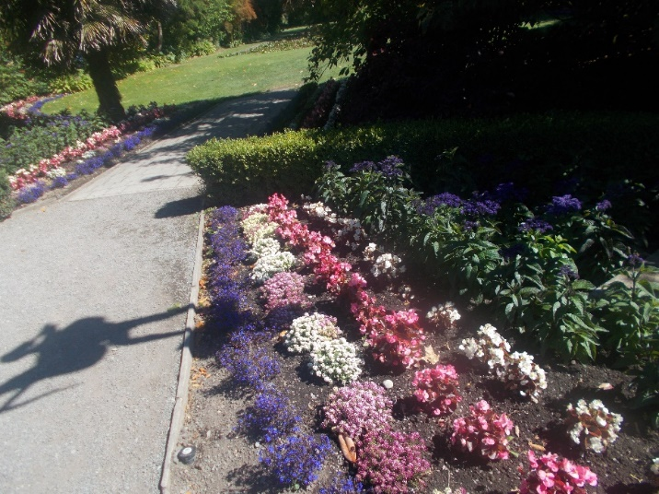
Beautiful Hernaceous Border at Mona Vale taken by Brian

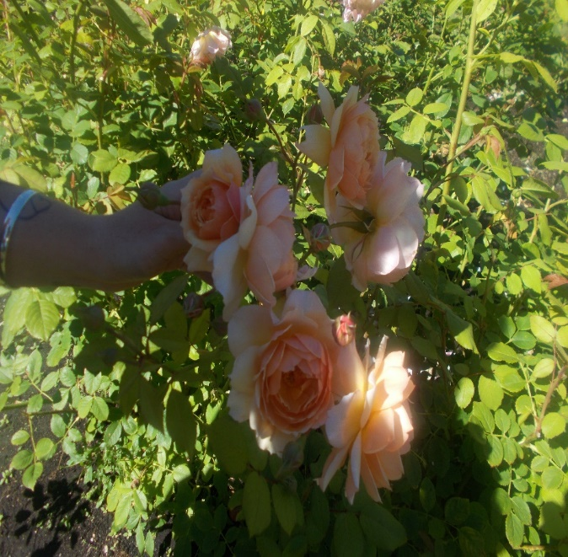
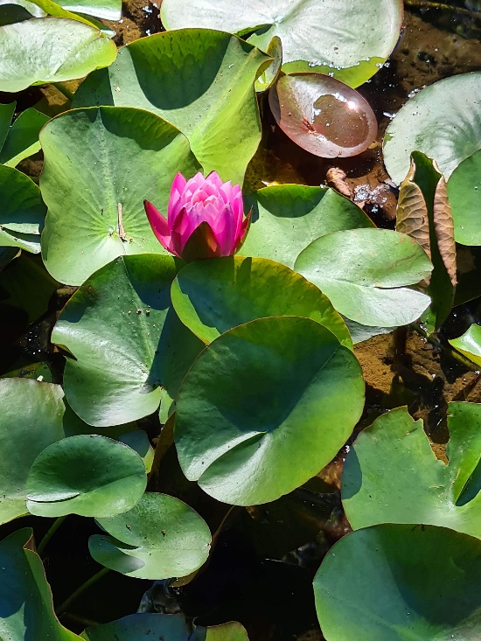
Brians photos of the beautiful roses and stunning lily from Mona Vale

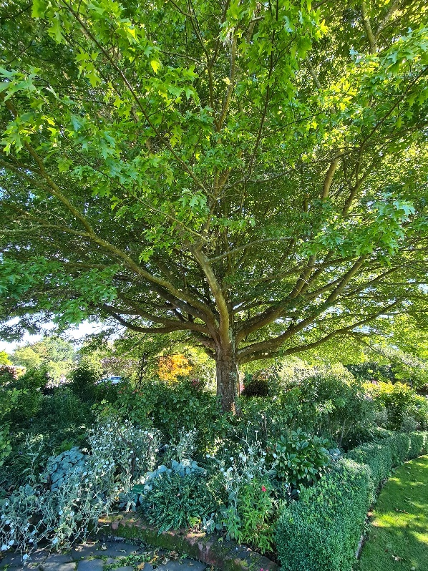
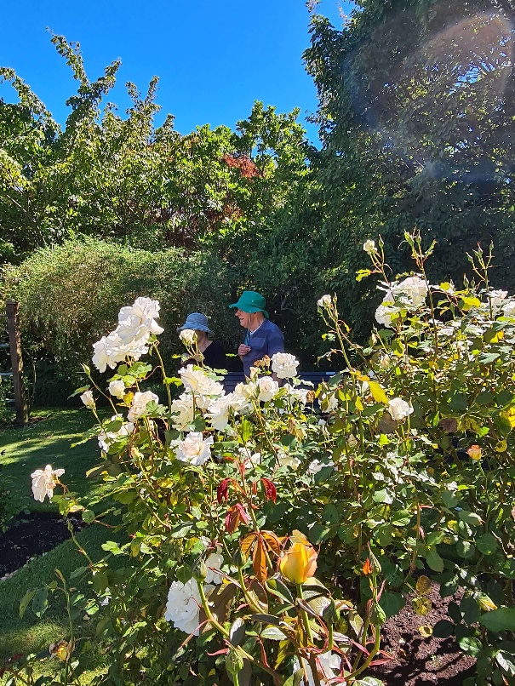

Janes photo of the lilys on the pond, a spectacular tree and Brian and Kathryn enjoying the Rose Garden at the Botannical Gardens
Pike Centre News-
“Welcome to 2021”
We are all back feeling energised and excited about what we can achieve at the Centre this year. With the day programmes starting back we are back into the swing of daily Centre life.
We ended last year with our Christmas break up day, it was a nice way to start off the festive season and holiday break.
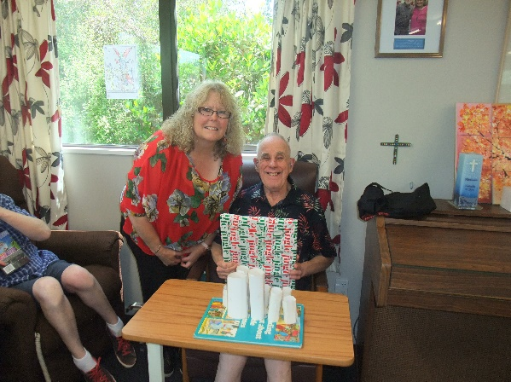
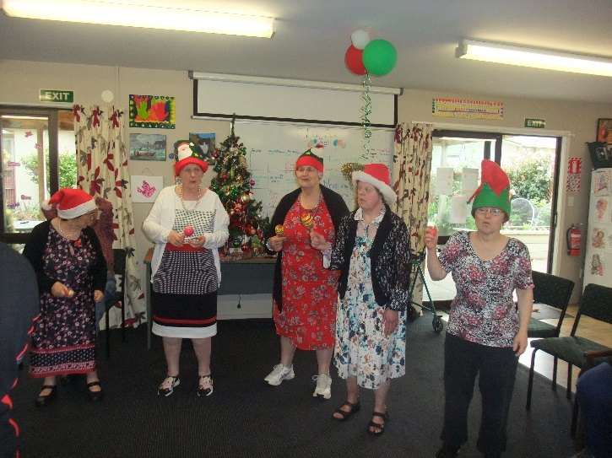

Exchanging Secret Santa gifts

Lots of dancing and singing thanks to Anne Glass and Mason Griffin who provided a lovely sing-along

The beginning of the year started with the annual Papanui Baptist Church picnic at Spencer Park, this was thoroughly enjoyed.

We held a planning meeting at the Pike Centre so we could decide what we would like to do for the next 6 months, there were a lot of suggestions and ideas.
One of the suggestions from this meeting was to have a word of the month. We have introduced this, including it into our day and Prayer Time on a Friday.
January = Kindness, February = Love.
From this came the idea of having an “Act of Kindness” week where we will each choose a person and do something kind for them.

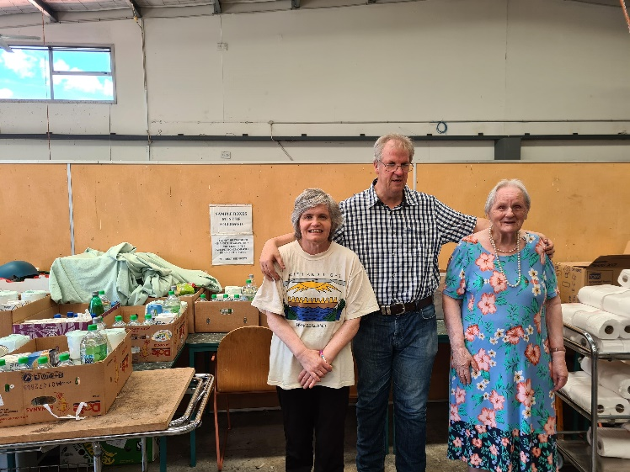
Several Community Members expressed that they would like to do some more volunteering. We contacted 0800 Hungry and went for a visit to see how this would go, everyone that attended really enjoyed this and stated how they would love to go back, so we have agreed to continue this and attend once a month.

Karen, Nigel, and Margaret really enjoyed packing up food parcels for people in need

During January we had a lot of fun searching for the penguins from the Pop-Up Penguin sculptures art trail that were scattered across Christchurch. It was exciting going out, keeping our eyes open, searching, and finding them all, each with their own different designs. When we returned to the Centre, we spoke about which were our favorites and decided that we would like to decorate our own penguins. We will put them on display around Marralomeda so watch this space………………
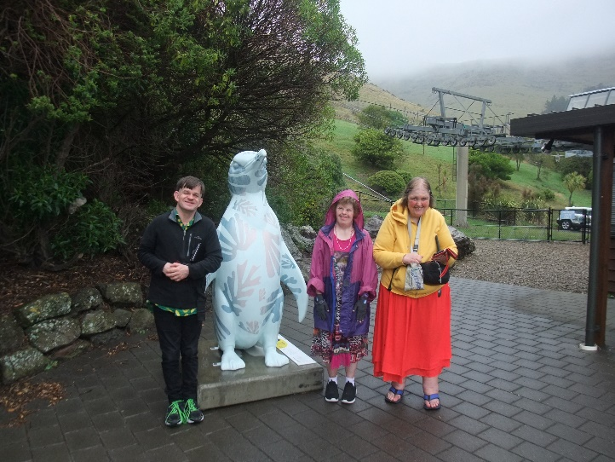
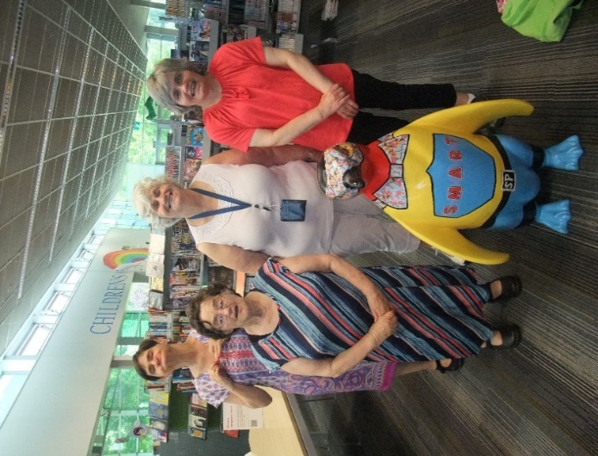

“The Penguin Hunters”

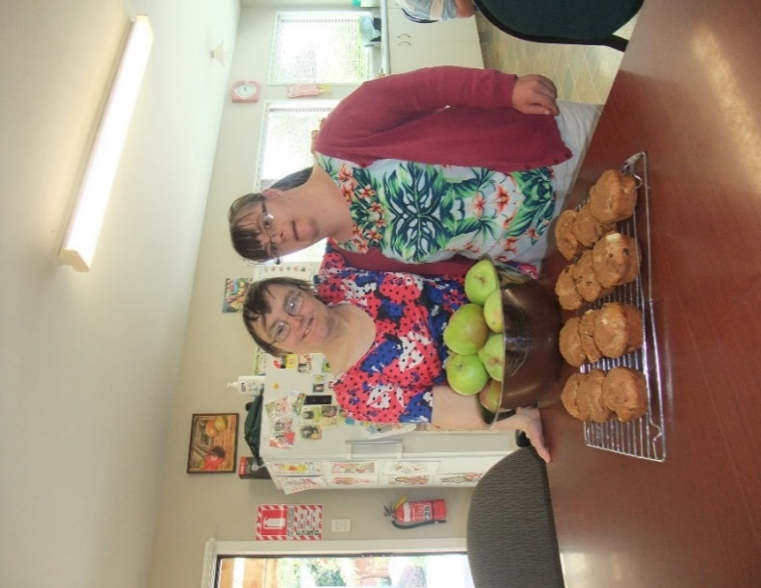
With Summer here we have had an abundance of produce. At the Centre we have putting this to great use. The apples have been cooked, frozen and turned into muffins. The plums have been made into plum jam. At afternoon tea we have been enjoying fresh tomatoes and carrots straight from the garden. YUM!

Jane and Amy enjoyed making apple muffins
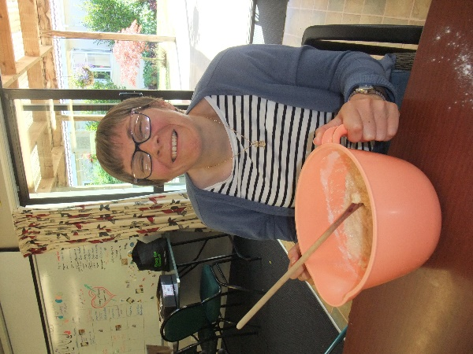

Sarah often uses her great baking skills to make yummy treats for visitors.

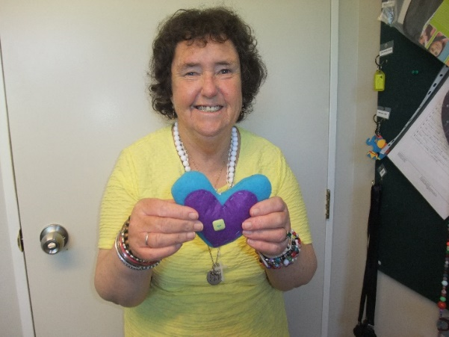

Susan loved making a Valentine’s Day gift using her hand sewing talents.

The start of 2021 has been busy, we are looking forward to sharing with you the fun and exciting things we have planned.
Love and Blessings from The Pike Centre.

This update was constructed with the help of Susan, Jane, Virginia, Jill, and Karen Hall

Staff Updates-
As we get closer to the opening of Annie Margaret House we would like to extend a warm welcome to our two new Residential Assistants, Lorna Wells who will be working at Annie Margaret house and Jack Singh who will be at McHale. Lorna has started her orientation at Ena Adams and the Pike Centre and Jack will be starting his orientation on the 1st of March at McHale and at the Pike Centre. We are delighted to have Lorna and Jack join the Marralomeda Community. We also had a number of other very good applicants, some of whom may join us as Community Support Workers and relievers.

Policy Update-
We have set up at three yearly cycle for reviewing our Policy and Procedure Manual. If you would like to view any of the Marralomeda Policies then please feel free to look at them in the house, the Pike Centre or the office. We have recently reviewed and updated the following Policies:
- Medical Needs
- Waste Management
- Medication (this is still a work in progress)
We are due to review the following Policies in the next few months:
- Privacy and Confidentiality
- Culturally Safe Services
- Community Members Rights and Responsibilities
- Abuse and Neglect
- Recognition of Individual Values and Beliefs
- Smoking and Vaping

We would also like to ensure everyone is aware of the Marralomeda Philosophy, Mission Statement and Values, which are attached.

PHILOSOPHY STATEMENT


Marralomeda is a Christian community where prayer is part of daily experience. As members of the Marralomeda Community the unique gift of each individual is recognised. The right to be listened to, loved and respected is paramount.

Although there are varieties of responsibilities there is no hierarchy of importance at Marralomeda. Each person in the community is accepted as they are and valued for who they are, their gift is precious to the community. Each person is accepted as “the light of Christ”.

Marralomeda is not only a service provider for persons with learning disability, it is a community where people come together to grow in bonds of friendship. Through walking with each other as we journey through the dailyness of our lives we celebrate our gifts and support each other in our various disabilities. No one person has all the gifts to make the community truly alive, therefore we rely on one another. Our disabled members often reveal to us our own preoccupation with the so-called “important” things of life and can forget how to enjoy life, to celebrate and to cherish relationships in a simple way.

Central to our philosophy is the concept of empowerment. We seek to empower our community members to make informed choices, to take responsibility for decisions and to contribute to all tasks pertaining to the running of their home and community to the level possible for each individual.

We believe in community integration and encourage our community members to participate in activities within the wider community and offer support to enable this to happen. Community integration is the key to public understanding of what the person with learning disability has to offer.

Hospitality is also central to Marralomeda philosophy. Whoever comes to the door is welcomed in an appropriate way and made to feel valued and important. We believe the busyness of daily life must never overtake the unexpected call to welcome. Relationships are fostered and family contact always encouraged.


Marralomeda Community

Mission Statement:
Enabling people with learning disability to have the dignity and quality of life that is their birthright.

Values | Fundamental Principles
Respect Everyone’s unique gifts are honoured
Acceptance Everyone is celebrated for who they are

Being of value Everyone and what they bring to the Marralomeda community is recognised and acknowledged

Inclusion Any barriers to living as part of the community are removed and discrimination is not tolerated

Hospitality We show manaaki (to look after, care for, show respect or kindness) to everyone who is part of or visits the Marralomeda community

Christian Prayer and action are important parts of daily life

Community Marralomeda is an important part of the Christchurch community. We celebrate this and work actively to ensure that this continues and grows

Mana Everyone has mana and has the right to be in control of their lives

Rite Tahi Everyone is of equal value

Interdependence We rely on each other and work together

Wellbeing Everyone is supported to be their best and have the life they want

